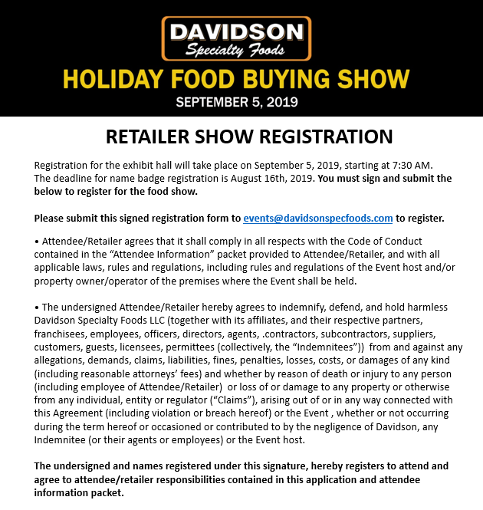
Retailer Name: _______________________________By: ______________________________
Printed Name: __________________________________________ Date: ________________
(authorized representative)
Title: _________________________________________________
Signature: ______________________________________________ Date: ________________

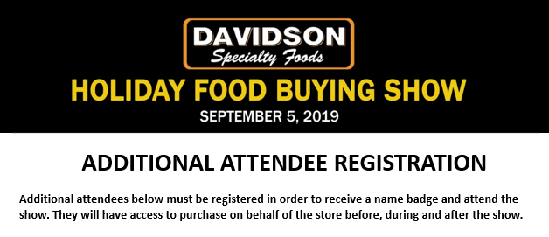
Attendee 1:
First & Last Name: ______________________________ Email: _____________________________
Store Name: __________________________________ Store Number: ______________________

Attendee 2:
First & Last Name: ______________________________ Email: _____________________________
Store Name: __________________________________ Store Number: ______________________

Attendee 3:
First & Last Name: ______________________________ Email: _____________________________
Store Name: __________________________________ Store Number: ______________________

Attendee 4:
First & Last Name: ______________________________ Email: _____________________________
Store Name: __________________________________ Store Number: ______________________

Attendee 5:
First & Last Name: ______________________________ Email: _____________________________
Store Name: __________________________________ Store Number: ______________________

Attendee 6:
First & Last Name: ______________________________ Email: _____________________________
Store Name: __________________________________ Store Number: ______________________

